Lead Website Updates:
Could the following area of the website be updated:
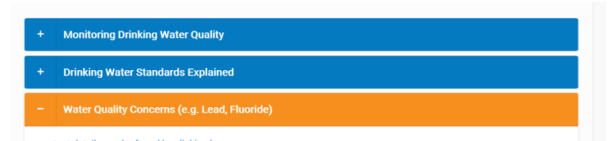
- Could a new tab be created - ‘Lead Pipes in your home’ and the below text added:

Lead
Water at its source and in mains is virtually lead free. However many properties still have lead plumbing and lead service pipes supplying the water into the house. If you live in a house built before 1970, chances are you may have lead pipework. Your drinking water can pick up lead from the pipework that runs from the water main underground and into your property, or from lead pipework inside your property. If you would like any further information relating to Lead please download our ‘Lead Pipes in your home Advice Leaflet’ here
The leaflet will provide you with information on:
- Where lead comes from
- Why lead can be a problem
- Where we sample and what we find
- What Portsmouth Water are doing about lead
- What to do if you think you have lead
- Could the Water Quality Concerns tab be updated to say ‘ Water Quality Concerns (e.g Fluoride, Nitrate) and then the section on lead removed from this area? This would leave information on Crypto, Nitrates, Pesticides and Fluoride

