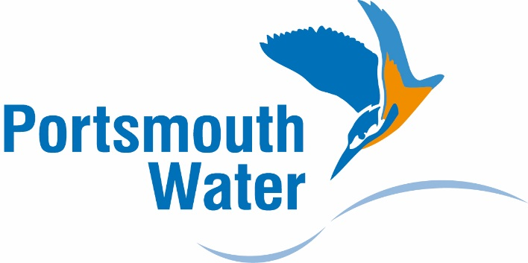

**Portsmouth Water’s Final Assurance Plan 2016/17**

**24 March 2017**

**Portsmouth Water’s Final Assurance Plan 2016/17**

**About this document**

The purpose of this document to publish our Final Assurance Plan for 2016/17.

This is the third and concluding document in this process.

The first stage of the exercise was to consult on a Statement of Risks, Strengths and Weaknesses, where we undertook a risk assessment of all technical data that will be presented in our Annual Performance Review. That consultation closed on the 12 December 2016.

The second stage of the exercise was to consult on our draft Audit Plan. This described our general approach to assurance, addressed some comments from our first consultation and proposed specific assurance actions for some of the key data items. That consultation closed on 1 March 2017.

We would like to thank all of our stakeholders who have commented on the previous two documents. This has allowed us to publish this Final Assurance Plan for the data we will publish on our performance in 2016/17.

C:\Users\sm\AppData\Local\Microsoft\Windows\Temporary Internet Files\Content.Outlook\2VXRQ0IV\benjamin signature (003).tif

**Heather Benjamin**

**Non-Executive Director and Chair of Audit Committee**

C:\Users\sm\AppData\Local\Microsoft\Windows\Temporary Internet Files\Content.Outlook\2VXRQ0IV\Orton Signature (002).tif

**Helen Orton**

**Finance & Regulation Director**

**Who we are**

We have been supplying water to Portsmouth and the surrounding area since 1857. The area supplied by the Company extends through South East Hampshire and West Sussex from the River Meon in the west to the River Arun in the east, encompassing 868 sq. km.

**Our vision**

To supply high quality drinking water whilst providing excellent levels of service for our customers at the lowest price in the country.

**Our values**

Our values underpin how we behave in delivering all aspects of our work. There are Excellence, Respect & Integrity.

**Contents**

|  |  |
| --- | --- |
| 1. Background | 4 |
| 2. Assurance Framework  3. Sources of Assurance | 5  5 |
| 4. Feedback from Stakeholders  5. Final Assurance Plan  6. Next Steps | 5  6  7 |
|  |  |
|  |  |

1. **Background** 
   1. We published our “Annual Performance Report” for the first time, reporting on the year 2015/16. It enabled stakeholders to assess how we performed against those measures of success that are regarded by our customers as being the most important factors (the “Performance Measures”). The targets for the Performance Measures were the commitment the Company made to its customers following extensive customer engagement exercise carried out when we were preparing our business plans for the 2015-2020 period.
   2. The Company recognise the importance of providing information to customers and other stakeholders that is; customer-led, relevant, reliable, complete, accurate and timely. Our ongoing objective is to make information available that is easy to understand and which enables stakeholders to see how we are performing; this helps build trust and confidence in the business.
   3. In June 2015 Ofwat published guidance, “The Company Monitoring Framework” which formalised the process through which they will oversee that stakeholders can have confidence in companies’ published Performance Measures.
   4. Ofwat has acknowledged that Companies and their Boards are best placed to identify the risks, strengths and weaknesses associated with providing such information. To allow us to develop a “targeted” assurance plan, in November 2016 we again undertook a risk assessment for all relevant non-financial data that will be contained in the Performance Report. This was an important exercise and was the basis of a Statement of Risks, Strengths and Weaknesses upon which we consulted. The consultation closed on the 12 December 2016. This statement is available on our website.
   5. The second stage of the exercise was to consult on our draft Audit Plan. This described the audit processes the Company either has or plans to have in place to provide third parties with the confidence that the data we provide is accurate. That consultation closed on 1 March 2017.
   6. Having regard to all discussions and comments received, we now publish this Final Assurance Plan to explain how stakeholders can be confident that the data we will report in the 2016/17 Annual Performance Report is of reliable and accurate.
2. **Assurance Framework** 
   1. The information that we publish on our performance will be assured by the Board to maintain and build a high level of trust and confidence from our customers and stakeholders.
   2. For this to be effective, performance needs to be reported in a clear way. In our draft Audit Plan, February 2017, we proposed to adopt a risk based approach to assurance, using internal and external review, to provide robust challenge and scrutiny of our performance. The feedback we received endorsed our approach.
   3. In addition, we regularly report performance measures to other bodies including CCWater, Drinking Water Inspectorate, Environment Agency, Health & Safety Executive, Natural England, Ofwat and Water UK. Further, we now report our performance on a regular basis to our Customer Challenge Group. This allows challenge and questioning of the data and performance in a timely manner.
3. **Sources of Assurance**

3.1 We consider that we already have robust processes and systems of control that provide the necessary assurance in respect of the reliability and completeness of the information published. For each of the Performance Measures, we will continue to apply these. However, in making this assessment we have performed robust challenges and sought feedback, as described in Section 1.

3.2 We have four levels of review. Our high level performance measures are reviewed at our monthly Board meeting, which the non-Executive Directors attend, with other performance measures reviewed at the monthly management Board meeting. Internally there is a weekly Operations meeting where certain KPIs are reviewed. This allows peer review to be undertaken. Further, the Audit Committee has a programme in place to monitor the quality of our data.

3.3 All our performance measures are subject to external review. This includes audits undertaken by our technical Reporter and our financial auditor. Details of our approach was published in our draft Audit Plan in February 2017.

1. **Feedback from stakeholders**

4.1 In total we have received feedback from 5 stakeholders, namely:

* Environment Agency
* CCWater
* Ofwat
* John Hall Consulting – West Sussex Growers Association
* Citizens Advice Havant
* Gosport Borough Council

Their feedback is reflected in our Assurance Plan shown in Section 5 which the Board of Portsmouth Water have endorsed.

**5. Final Assurance Plan 2016/17**

5.1 Our Annual Performance Report is the primary way that we will document our annual performance and hold ourselves publicly to account. The Annual Performance Report includes:

* our Statutory Accounts – audited separately by Saffery Champness;
* our Annual Performance Report audited by Atkins
* other information to explain more broadly our performance against our commitments and responsibilities to stakeholders and customers

**Performance Commitments and Outcome Delivery Incentives (ODIs)**

5.2 Our Business Plan for the period 2015–20 made 13 promises to our customers with a clear set of targets to deliver by 2020.

5.3 In addition, our stakeholder engagement exercise highlighted opportunities to improve reporting in specific areas namely;

* Providing trend performance data, where appropriate
* Providing comparative performance data for key areas;
* Delivering against the National Environment Plan; and
* Reporting on the management of our one Site of Special Scientific Interest at the river Itchen (SSSIs) and the delivery against our Water Resources Management Plan;

5.4 The points 1 to 4 above will be specifically included within the Annual Performance Report and will be reviewed and commented upon by the Reporter (Atkins).

**6. Next Steps**

6.1 This plan will be published on our website and distributed to our stakeholders. We will discuss it explicitly at our next Customer Challenge Group and deliver the detailed audit programme to meet the expectation of all stakeholders.

6.2 Our Annual Performance Review for 2016/17 will then be published by 15 July 2017.