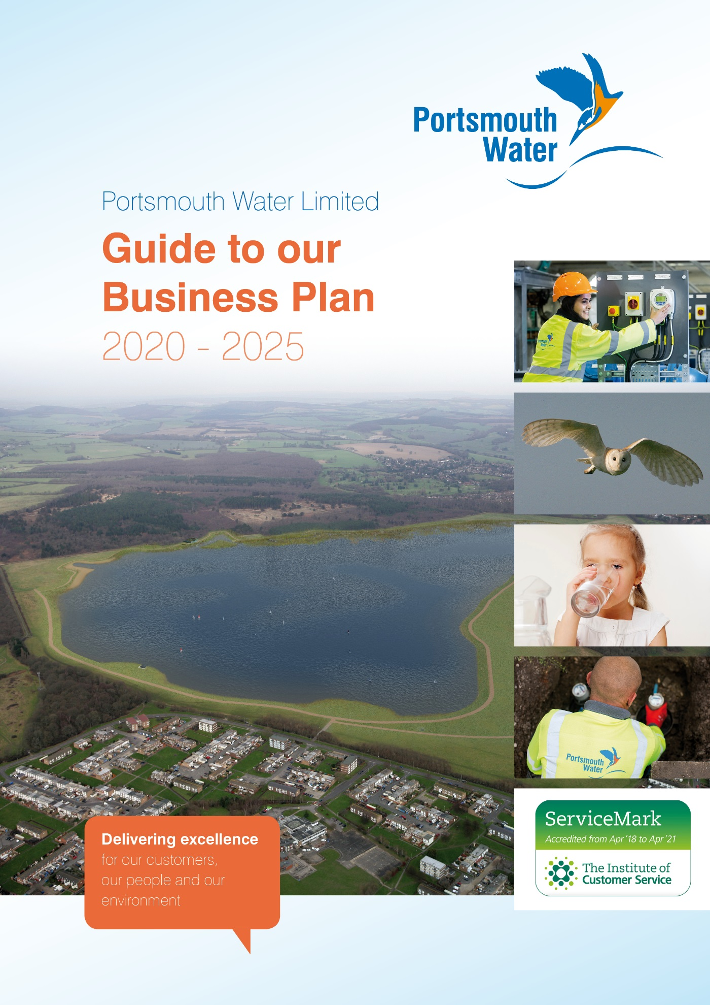

Introduction
This Guide summarises the structure of our Business Plan and sign-posts how it may be readily navigated, together with how it aligns to the areas set out in the Initial Assessment of Plan (IAP) tests. It should be used in connection with the Business Plan document itself and the IAP proforma.
Structure of our Plan
Our plan is set out in 13 Chapters, including the Executive Summary. It is further supported by Appendices which have been summarised in the same structure together with a set of “modelling” files in Appendix 14. Additionally a glossary of terms is included at the end of the document for reference purposes.
Appendices are referenced from the body of the text and, for ease of reference a table of relevant Appendices has been included at the end of each Chapter or Section.
Whilst we have aligned the plan as closely as possible to both the structure of the IAP and the Ofwat “four pillars” the interrelated nature of the different elements means that, inevitably, there are elements that cross over between sections of the IAP. This is particularly evident in articulating how customer engagement links through to Outcomes and Performance Commitments and, ultimately how these will be delivered. This is covered primarily in Chapter 3 of our Business Plan.
Within Chapter 3 – Delivering Customer Outcomes, the initial sections 3.1 to 3.5 cover the process of establishing Outcomes through to determining rewards and penalties. Sections 3.6 to 3.12 cover each of our Outcomes together with the Performance Commitments to which they relate. Finally, 3.13 signposts how our Plan delivers statutory responsibilities and our Stakeholders’ strategic priorities.
We cover the Ofwat “4 Pillars” in Chapters 4 to 7 of our Plan. However, it should be recognised that these themes run throughout our Plan.
Our significant new water resources project – Havant Thicket Winter Storage Reservoir is covered in Chapter 8 – together with other market driven activities.
All aspects of cost efficiencies, including a summary of enhancement activity, is included in Chapter 9.
Financial aspects relating to risk and return are included in Chapters 10 and 11. AMP6 performance is covered in Chapter 12.
Finally, Assurance is covered in a separate Board Assurance Statement, together with the summary of assurance and summary of the CCG Report in Chapter 13.
The Plan is supported by separate documents – the Board Assurance Statement and the report from our CCG.
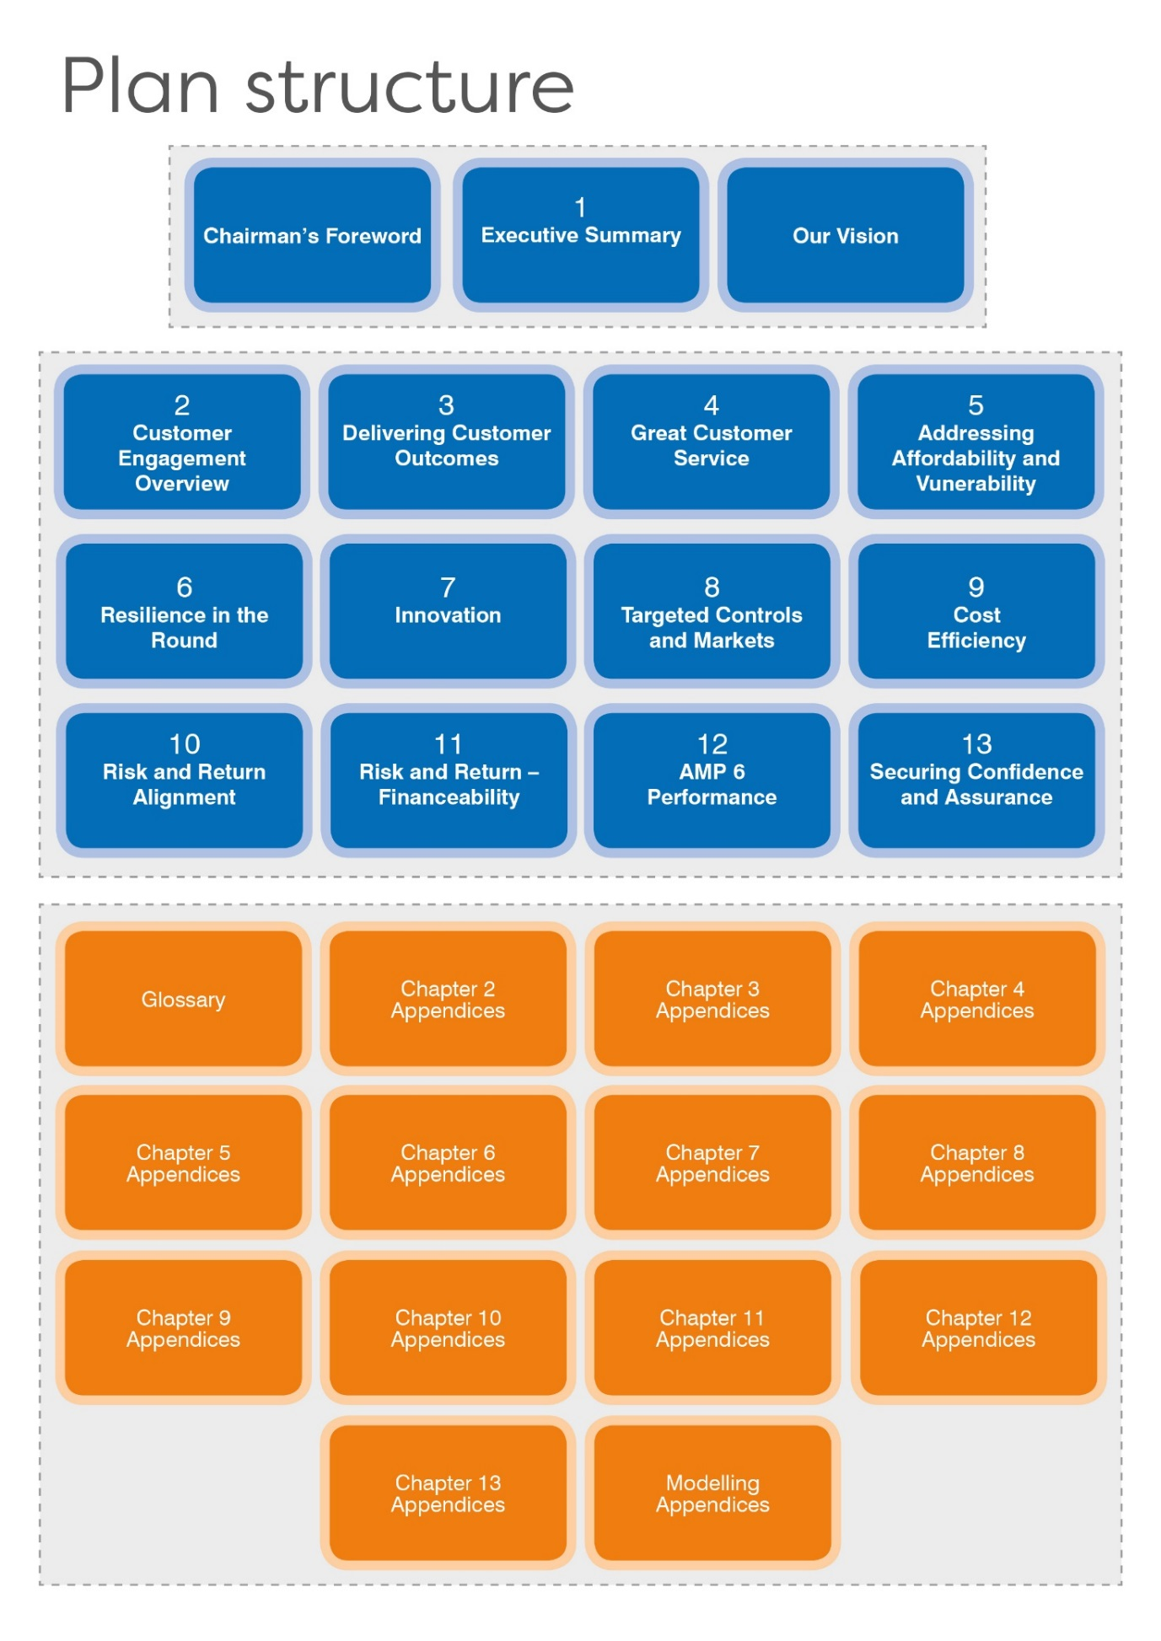

Alignment to IAP Areas
This table summarises the broad alignment between our Business Plan chapters and the IAP areas. It should be read in conjunction with the more detailed IAP proforma.
Area | Test |  | Chapter & Document | Reference
Engaging customers | EC 1 |  | Chapter 2  Chapter 3  Chapter 4  CCG report | Pages 8-14  Pages 34-86  Pages 91-96  Pages 5-8
Addressing affordability and vulnerability | AV 1 |  | Chapter 3  Chapter 4  Chapter 5  Chapter 11 | Pages 62-69 & 79-84  Page 93-94  Pages 97-105  Pages 178-181
Addressing affordability and vulnerability | AV 2 |  | Chapter 3  Chapter 4  Chapter 5  Chapter 11 | Pages 62-69 & 79-84  Page 93-94  Pages 97-105  Pages 178-181
Addressing affordability and vulnerability | AV 3 |  | Chapter 3  Chapter 4  Chapter 5  Chapter 11 | Pages 62-69 & 79-84  Page 93-94  Pages 97-105  Pages 178-181
Addressing affordability and vulnerability | AV 4 |  | Chapter 3  Chapter 4  Chapter 5  Chapter 11 | Pages 62-69 & 79-84  Page 93-94  Pages 97-105  Pages 178-181
Delivering outcomes for customers | OC 1 |  | Chapter 3  Chapter 10  Chapter 11 | Pages 15-33  Pages 159-167  Pages 178-180
Delivering outcomes for customers | OC 2 |  | Chapter 3  Chapter 10  Chapter 11 | Pages 15-33  Pages 159-167  Pages 178-180
Delivering outcomes for customers | OC 3 |  | Chapter 3  Chapter 10  Chapter 11 | Pages 15-33  Pages 159-167  Pages 178-180
Securing long-term resilience | LR 1 |  | Chapter 3  Chapter 6  Chapter 9 | Pages 39-40 & 45-54  Pages 106-121
Securing long-term resilience | LR 2 |  | Chapter 3  Chapter 6  Chapter 9 | Pages 144-146
Targeted controls, markets and Innovation | CMI 1 |  | Chapter 3  Chapter 4  Chapter 6  Chapter 7  Chapter 8  Chapter 9 | Pages 45-54  Page 96  Pages 106-121  Pages 122-128  Pages 130-138  Pages 141-153
Targeted controls, markets and Innovation | CMI 2
Targeted controls, markets and Innovation | CMI 3
Targeted controls, markets and Innovation | CMI 5
Targeted controls, markets and Innovation | CMI 6
Targeted controls, markets and Innovation | CMI 7
Securing cost efficiency | CE 1 |  | Chapter 8  Chapter 9 | Pages 130-137  Pages 141-152
Securing cost efficiency | CE 3 |  | Chapter 8  Chapter 9 | Pages 130-137  Pages 141-152
Securing cost efficiency | CE 4 |  | Chapter 8  Chapter 9 | Pages 130-137  Pages 141-152
Aligning risk and return | RR 1 |  | Chapter 10  Chapter 11  Board Assurance Statement | Pages 155-167  Pages 168-183  Pages 8-9
Aligning risk and return | RR 2 |  | Chapter 10  Chapter 11  Board Assurance Statement | Pages 155-167  Pages 168-183  Pages 8-9
Aligning risk and return | RR 3 |  | Chapter 10  Chapter 11  Board Assurance Statement | Pages 155-167  Pages 168-183  Pages 8-9
Aligning risk and return | RR 4 |  | Chapter 10  Chapter 11  Board Assurance Statement | Pages 155-167  Pages 168-183  Pages 8-9
Accounting for past delivery | PD 1 |  | Chapter 12 | Pages 184-196
Accounting for past delivery | PD 2 |  | Chapter 12 | Pages 184-196
Securing confidence and assurance | CA 1 |  | Chapter 3  Chapter 11  Chapter 13  Board Assurance Statement | Page 83 & 86-90  Pages 170-173, 181-183  Pages 197-199  Pages 3-4 & 6
Securing confidence and assurance | CA 2 |  | Chapter 3  Chapter 11  Chapter 13  Board Assurance Statement
Securing confidence and assurance | CA 3 |  | Chapter 3  Chapter 11  Chapter 13  Board Assurance Statement
Securing confidence and assurance | CA 4 |  | Chapter 3  Chapter 11  Chapter 13  Board Assurance Statement
Securing confidence and assurance | CA 5 |  | Chapter 3  Chapter 11  Chapter 13  Board Assurance Statement
Securing confidence and assurance | CA 6 |  | Chapter 3  Chapter 11  Chapter 13  Board Assurance Statement

Plan guide
This table gives a precis of the Chapter and Sections contents in our Plan.
Chapter |  | Section | Main Section Headings | Brief Description
 | Our Chairman’s Foreword |  | Chairman’s overview of our Plan.
 | Contents
1 | Introduction | 1.1 | Executive Summary | A five page summary of the Plan
1 | Introduction | 1.2 | Our long term vision | Sets out our long term vision for customer service, regional water resilience and the environment, through to 2050.
2 | Customer Engagement Overview | 2 | An overview of our engagement journey, explaining our approach and planning cycle.
2 | Customer Engagement Overview | 2.1 | Key Engagement Activities that shaped our plan | Summary of the key pieces of research that shaped our Plan.
2 | Customer Engagement Overview | 2.2 | Business Plan Research and Triangulation – Key Messages | Key customer insights gained in preparing this Plan.
2 | Customer Engagement Overview | 2.3 | How has engagement influenced our plan | Table showing how customers’ views have driven our Plan.
3 | Delivering Customer  Outcomes |  | This Chapter covers how our PR19 Outcomes and Performance Commitments were developed, the engagement that supports them, what they are and what our plan will deliver.
3 | Delivering Customer  Outcomes |  | The first sections 3.1 to 3.5 set out how Outcomes, Performance Commitments, Service Levels and ODI Rewards and Penalties have been established.
3 | Delivering Customer  Outcomes | 3.1 | Background | Brief details of how our ODI framework has been established.
3 | Delivering Customer  Outcomes | 3.2 | Establishing the Outcomes | The evolution of outcomes from PR14 to PR19.
3 | Delivering Customer  Outcomes | 3.3 | Establishing the Outcome Delivery Incentives | The steps in the process of establishing Performance Commitments, determining stretching Service Levels and establishing rewards and penalties.
3 | Delivering Customer  Outcomes | 3.4 | RoRE of ODI package | Assessment of the overall ODI package and benchmarking against the RoRE range.
3 | Delivering Customer  Outcomes | 3.5 | Disseminating performance information effectively | An explanation of how we will share performance information effectively with customers and stakeholders, to enhance trust and legitimacy.

Chapter |  | Section | Main Section Headings | Brief Description
3 | Delivering Customer  Outcomes |  | The following Sections cover each of our Outcomes and related Performance Commitment. Each section gives further detail on the relevant customer engagement and explains how the Outcome and related Performance Commitments will be delivered.
3 | Delivering Customer  Outcomes | 3.6 | Safe, Secure and Reliable supply of drinking water | This section covers engagement undertaken and the Performance Commitments associated. There are seven Performance Commitments related to this Outcome, Water Quality Compliance, Customer Contacts, Unplanned Outage, Resilience Schemes, Mains Burst, Supply Interruptions and Properties at risk of low pressure.
3 | Delivering Customer  Outcomes | 3.7 | Long Term resilience of supplies for our own customers and to support the South East Region | This section covers our plans to deliver more resilient water resources for the South East. It also covers engagement undertaken and the Performance Commitments associated. There are three Performance Commitments; PCC, Risk of severe restrictions in drought and Requirement to introduce Temporary Use Bans.
3 | Delivering Customer  Outcomes | 3.8 | Low leakage | This section covers engagement undertaken and the Performance Commitments associated. There is one Performance Commitment related to Low Leakage, which is a leakage reduction target.
3 | Delivering Customer  Outcomes | 3.9 | A service tailored to individual needs at a long term affordable price | This section covers engagement undertaken and the Performance Commitments associated. There are four Performance Commitments; C-Mex, D-Mex, Affordability and Void Properties and Gap Sites.
3 | Delivering Customer  Outcomes | 3.10 | An improved environment, supporting biodiversity | This section covers engagement undertaken and the Performance Commitments associated. There are four Performance Commitments; Biodiversity, Catchment Management, AIM and Carbon.
3 | Delivering Customer  Outcomes | 3.11 | Being recognised by the community as a good corporate citizen | This section covers engagement undertaken and the Performance Commitment associated. There is one Performance Commitment related to satisfaction of our vulnerability management.
3 | Delivering Customer  Outcomes | 3.12 | Recognised by stakeholders as having a culture of Health and Safety | This section covers engagement undertaken and the Performance Commitment associated. There is one Performance Commitment; the Annual President’s award, from RoSPA.
3 | Delivering Customer  Outcomes | 3.13 | Delivering Statutory Responsibilities | This provides a summary of how the Plan meets the statutory requirements placed on Portsmouth Water. There is also a summary of how the Plan addresses the strategic priorities of UK Gov and other key stakeholders.

Chapter |  | Section | Main Section Headings | Brief Description
4 | Great Customer Service | This Chapter explains how we serve customers, our service culture and how we measure our service levels.
4 | Great Customer Service | 4.1 | Customer Service Overview | How we compare service with others, help those at times of vulnerability, serve developers, react to customer feedback, drive a customer service culture and innovate.
5 | Addressing Affordability & Vulnerability | This Chapter looks at Affordability (including how we meet Ofwat’s five principles) and Vulnerability.
5 | Addressing Affordability & Vulnerability | 5.1 | Affordability | How we manage affordability in line with Ofwat’s five principles, and how we will achieve affordability in the long term.
5 | Addressing Affordability & Vulnerability | 5.2 | Vulnerability | How we effectively manage vulnerability. This includes how we use data, engage with third parties, and achieve a targeted approach.
6 | Resilience in the round | The Chapter explains all aspects of resilience.
6 | Resilience in the round | 6.1 | Background | Our foundations of resilience for infrastructure, drought, and floods.
6 | Resilience in the round | 6.2 | Our approach to Resilience and alignment with Ofwat’s Resilience Principles | How our approach to resilience aligns to Ofwat’s seven resilience principles.
6 | Resilience in the round | 6.3 | Governance and Corporate Resilience | Overview of how we manage risk and resilience within Portsmouth Water.
6 | Resilience in the round | 6.4 | Work Activity Undertaken to Support the Business Plan for 2020-2025 | Explanation of the work undertaken to support our approach to resilience in the Business Plan. This includes our resilience planning approach based on the Cabinet Office’s 4R’s.
6 | Resilience in the round | 6.5 | Specific Interventions at PR19 | Studies and assessments relevant to this plan.
6 | Resilience in the round | 6.6 | Our People and Skills for the Future | Workforce related resilience activities.
6 | Resilience in the round | 6.7 | Conclusions and Inclusions in the Business Plan 2020-2025 | Overall conclusions together with the additional resilience projects included at PR19.
7 | Innovation | This Chapter covers our culture, evidence of past innovation and examples of innovation for PR19.
7 | Innovation | 7.1 | Innovation Culture; Systems and Processes | How our systems and processes support and drive innovation.
7 | Innovation | 7.2 | Innovation Culture; People | How our People drive innovation, including how we inform, enable, incentivise and collaborate to achieve innovation.
7 | Innovation | 7.3 | Our Innovation Track Record | Examples of innovative approaches already introduced by Portsmouth Water.
7 | Innovation | 7.4 | PR19 Innovation | Innovative approaches and activities planned for PR19.

Chapter |  | Section | Main Section Headings | Brief Description
8 | Targeted Controls & Markets | How we engage with markets to deliver the best solutions for our Customers and the South East region.
8 | Targeted Controls & Markets | 8.1 | Water Resources Trading – Havant Thicket Winter Storage Reservoir | Explanation of the support for our proposal to build a new winter storage reservoir at Havant Thicket. This includes consideration of DPC, overall business case and uncertainty mechanisms.
8 | Targeted Controls & Markets | 8.2 | Bid Assessment Framework | Summary of the framework that we have developed.
8 | Targeted Controls & Markets | 8.3 | RCV Allocation and Bi-lateral Markets | Our methodology and proposed RCV split and our assessment of potential impact of Bi-lateral markets.
8 | Targeted Controls & Markets | 8.4 | Retail | Our plans for managing Voids and Gap Sites and lessons learnt from the Business Retail Market.
9 | Cost Efficiency | This Chapter deals with wholesale and retail efficiency
9 | Cost Efficiency | 9.1 | Totex Efficiency (Wholesale) | A summary of Totex for AMP 7, benchmarking and use of markets, innovative models, optimising of approaches, use of technology, and targeted efficiency savings.
9 | Cost Efficiency | 9.2 | Retail Efficiency | Bad debt and Input price pressures.
9 | Cost Efficiency | 9.3 | Cost Efficiency – Enhancements expected | Details of twelve schemes that qualify as enhancements.
10 | Risk and Return Alignment | This Chapter deals with the factors contributing to how risk and return align within the Business Plan.
10 | Risk and Return Alignment | 10.1 | WACC and Retail Margin | Table summarising the build-up of our WACC and confirmation that a Retail Margin of 1% has been applied to the Retail Control.
10 | Risk and Return Alignment | 10.2 | Company Specific Premium | Evidence of support for Company Specific Premium and level of adjustments sought.
10 | Risk and Return Alignment | 10.3 | Risks and Mitigation | How the Company has reviewed and mitigated delivery risks associated with our Plan and how these link to RoRE scenarios.
10 | Risk and Return Alignment | 10.4 | RoRE Upside/Downside | RoRE modelling against various scenarios.

Chapter |  | Section | Main Section Headings | Brief Description
11 | Risk and Return - Financeability | This chapter covers our financeability based on our proposed plan.
11 | Risk and Return - Financeability | 11.1 | Board statement on financeability | The Board’s review of financeability and their conclusions.
11 | Risk and Return - Financeability | 11.2 | Financial resilience | Financeability tested against the number of specific scenarios.
11 | Risk and Return - Financeability | 11.3 | Assessment of financeability | Conclusion on financeability on both a notional and actual basis. This includes financeability adjustments
11 | Risk and Return - Financeability | 11.4 | Dividend policy | The basis of which it is intended that dividends will be paid.
11 | Risk and Return - Financeability | 11.5 | Gearing outperformance sharing mechanism | Our proposal mechanism in respect of sharing the benefit of high gearing.
11 | Risk and Return - Financeability | 11.6 | Ownership Structure | Explanation of how Portsmouth Water Limited fits in with the overall group structure.
12 | AMP 6 performance | This Chapter covers our AMP 6 Performance relative to our Performance Commitments and resultant rewards and penalties
12 | AMP 6 performance | 12.1 | Reconciliation for 2015-2020 | Reconciliation of performance during AMP 6.
12 | AMP 6 performance | 12.2 | Overview of our Performance | Highlights from AMP6
12 | AMP 6 performance | 12.3 | Our promises to our Customers | Performance against our AMP6 Targets
13 | Securing Confidence and Assurance | Details of Assurance activities and our summary of our CCG’s report – This should be read in conjunction with the separate Board Assurance Statement
13 | Securing Confidence and Assurance | 13.1 | Summary of Assurance | Summary of how our plan has been assured by external parties
13 | Securing Confidence and Assurance | 13.2 | Our Summary of CCG Report | Our summary of the CCG’s Report which is provided separately in full.

