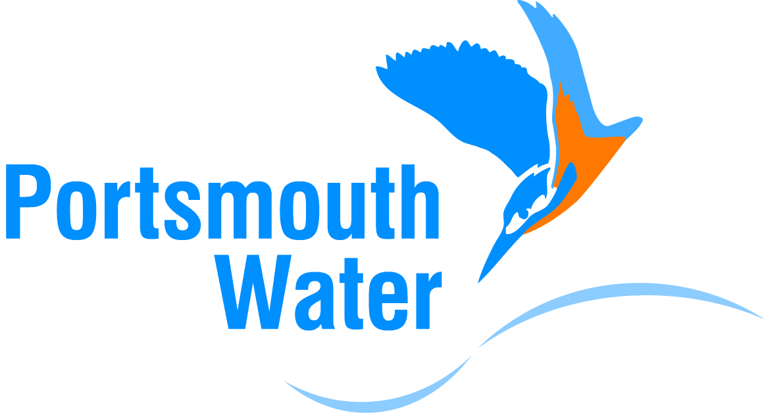

Production Water Quality Sampler

Salary £16,509 to £21.375 Pro rata (Grade 2)
26.25hr Week, Mon-Fri 08:00-14:00
12 Month contract

Hampshire/West Sussex

We are recruiting for two Water Quality Samplers to work in our Production Operational Department. The department consists of a multi-disciplined team that are responsible for the day to day operation of Portsmouth Water’s production assets.

Essential duties and responsibilities may include, but are not limited to the following:

- Visiting water treatment works, pumping stations, reservoirs.
- Taking water quality samples.
- Periodic cleaning of sampling facilities to maintain the appearance, cleanliness and operability of our sample locations.

The successful applicant will be self-motivated, computer and smart phone literate, flexible and have good attention to detail, working as part of a team ensuring all work is carried out in line with the Company’s procedures and in full compliance with on-site Health and Safety. You will be willing to develop and learn within the role working at all times in line with our values of excellence, integrity and respect.

The role requires the following qualifications;

- A to C grade GSCE English and Maths (or equivalent).
- Full UK driving licence. You will be required to undertake our Driver Assessment.

You will be required to undergo training (that will be provided) and pass a National Water Hygiene course and UKAS accreditation for water sampling.

For an informal discussion please contact Mark Botterill on 07738 883796

Applicants should send a CV outlining their salary expectations with two referees.

Apply to: Ian Limb, Head of HR, PO Box 8, Havant, Hants PO9 1LG

Closing Date: 8 November 2019

E-mail: jobs@portsmouthwater.co.uk

