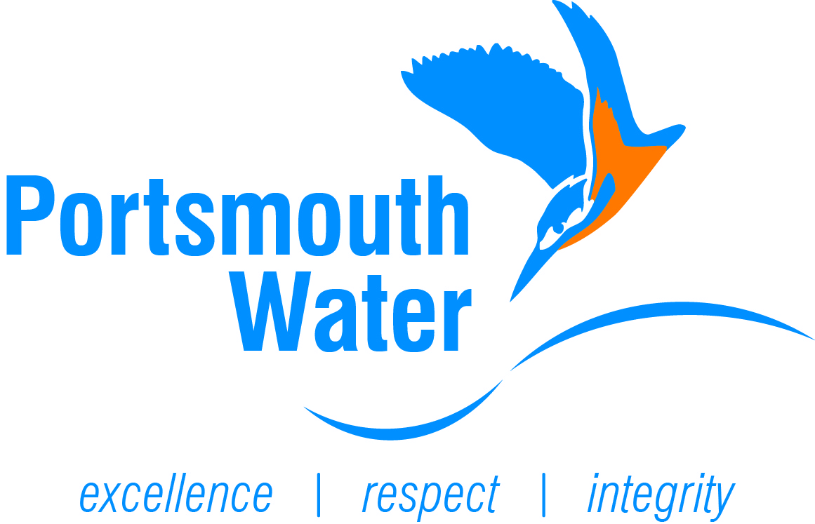

JOB DESCRIPTION

Job Title | Senior Catchment Management Officer | Grade | 7
Version | December 2020
Reporting To | Catchment and Environment Manager
Department | Catchment and Environment Team
Location | Havant (Water Resource, Leakage and Smart Networks)
Direct Reports | Catchment and Environment Officer
Responsible for | Delivery of Catchment Management Programme
Key Interfaces | Internal:  - Catchment and Environment Team  - Liaise with Company Sectary on agricultural tenancies  - Water Quality department  - Liaise with Water Resources Lead  - Liaise with Regulations Lead  External:  - Most of the work involves liaising with farmers and landowners  - Catchment Partnerships including Downs and Harbours Clean Water Partnership  - Farmer Cluster Groups (e.g. South Downs Farmers Group)  - Work closely with regulatory authorities (e.g. Environment Agency, Natural England/ Catchment Sensitive Farming, NFU and CLA) and other relevant parties  - Work closely & reports to regulators (e.g. Environment Agency, Natural England & OWFAT)
Purpose of role | To advise farmers in Portsmouth Water groundwater catchments to encourage them to reduce or make more efficient use of nutrients in particular nitrogen (and other parameters such as pesticides, turbidity, cryptosporidium) in order to remove the need for treatment for these parameters at Portsmouth Water treatments works. To lead on multiple projects and campaigns related to water quality (e.g. catchment research projects).
Values and Behaviours
We build success through a collaborative approach and by developing sustainable relationships. We will endeavour to provide a better service for both our internal and external customers and our colleagues. We will achieve this by following the Portsmouth Water core values:

- Excellence - Customer service excellence, Commercial awareness, Quality mind-set & drive for results, Innovation & continuous improvement, Adaptable & positive attitude.

- Integrity - Planning & organising, Building trust & reliability, Decision making & ownership, communicating clearly.

- Respect - Environmental awareness, Co-operative teamwork, Working safely & following the rules.

Task List

- Co-ordinate and lead on the delivery of Portsmouth Water catchment incentive schemes (Farmer Capital Grant Scheme and ‘Payments for Ecosystem Services’ scheme) that rewards farmers in target catchments for adopting farming practices which result in lower nutrient and pesticide losses to water
- Key Catchment Management and agronomy lead contact for the Company
- Delivery of solo and joint farm engagements visits
- Take a strategic approach to how Portsmouth Water’s catchment resources are applied to high nitrate groundwater sites, including the nature of the engagement, incentives and monitoring
- Lead on communications for Catchment Management (e.g. farm events)
- Provide agronomy advice and support with nutrient, manure and soil management to farmers and relevant landowners
- Lead on catchment research and trial work
- Lead and review Risk Assessments related to key responsibilities
- Key support for DWSP Rural Catchment Risk Assessments
- Design and implement monitoring strategies / programmes to measure the impact of changes in land-use and practices adopted by farmers on nitrate leaching to groundwater
- Lead on regulatory work and consultations related to Catchment Management
- Lead on environmental programme reporting requirements (e.g. Catchment WINEP programme)
- Budget management and reporting of Downs and Harbours Clean Water Partnership and support Catchment Management Plan budgets
- Preparation & delivery of internal and external reports
- Additional formation of farm cluster groups & working groups in the catchment

Key Responsibilities

Health and Safety

- To comply with all policies and procedures relating to Health and Safety.
- To proactively protect the wellbeing of all members of the Catchment and Environment Team.

Customer Service

- Delivering excellent customer service when dealing with internal and external customers.
- Encourage proactive and effective communications to help develop and maintain professional relationships with internal and external customers.
- Promoting and demonstrating continuous improvements to procedures/processes/working practices to enhance the level of customer service delivery across all functions of business activity.

Performance and Service Delivery

- Ensure that all network operations are undertaken in an appropriate manner with due consideration and planning. That all operations are completed in line with the relevant PW policies/procedures/RAMS.
- To monitor, review and report on all key activities within area of responsibility and recommend process improvements to maintain/enhance PW performance to ensure that all internal and external standards, targets and requirements are achieved/exceeded.

Personnel

- Encourage a collaborative working culture across all interactions.
- Demonstrate and promotion of PW Company Values and behaviours.
- To provide leadership, support and regular communication to the other members of the Catchment and Environment Team.
- To undertake relevant inspections/audits to ensure team performance and standards are maintained.
- To effectively manage personnel performance and discipline in line with company values.
- Investigation and reporting of any near miss or actual near miss accidents/incidents.

Compliance

- Encourage compliance with agreed Department KPI’s and SLA’s.
- Delivery of WINEP and ODI measures
- Ensure that all department processes, procedures and standards are met in accordance with specification and to very high and consistent level.

In addition to the above, the role will also include various tasks relevant to this role and will vary depending on business and departmental requirements.

Person Specification

Skills, Competencies & Qualifications

- Strong agricultural knowledge and experience is essential
- A degree (or equivalent) in an environmental science discipline or a related discipline
- BASIS Foundation qualification required (Soil and Water) or equivalent
- Additional BASIS qualifications desirable
- FACTS qualification is highly desirable
- Strong scientific and technical skills in agronomy and catchment management
- Ability and experience in talking to and dealing with the farming community is vital
- Knowledge of soils and soil/nutrient/manure management
- Ability to work well both in a team and by oneself representing Portsmouth Water in the field
- Comprehensive hydrogeological & hydrological understanding
- Comprehensive computer literacy skills
- Strong administration and organisation skills
- Project Management skills
- Coaching & mentoring skills
- Understanding and experience of working in environmental field and understanding of grant/funding schemes (e.g. agri-environmental schemes)
- Excellent written and verbal communication skills are required
- Full UK driving license required

This role description gives the post holder an understanding of the range of duties to be undertaken as part of the role. It does not detail every activity that will be required of the post holder. Specific tasks and objectives will be agreed with the post holder as necessary according to changing business requirements, priorities, and operational needs.

